**Name: Year 9 - Mapping the world and Interconnections:**

Practice mapping **10** of these cities on your world map:

1896 - Athens, Greece  
1900 - Paris, France  
1908 - London, United Kingdom  
1912 - Stockholm, Sweden  
1920 - Antwerp, Belgium  
1928 - Amsterdam, Netherlands  
1932 - Los Angeles, United States  
1936 - Berlin, Germany  
1952 - Helsinki, Finland  
1960 - Rome, Italy  
1968 - Mexico City, Mexico  
1976 - Montreal, Canada  
1988 - Seoul, South Korea  
1992 - Barcelona, Spain  
2000 - Sydney, Australia  
2008 - Beijing, China  
2016 - Rio de Janeiro, Brazil  
2020 - Tokyo, Japan

Can you guess what the above list is referring to? ___________________________

**Brainstorm on types of transport:**

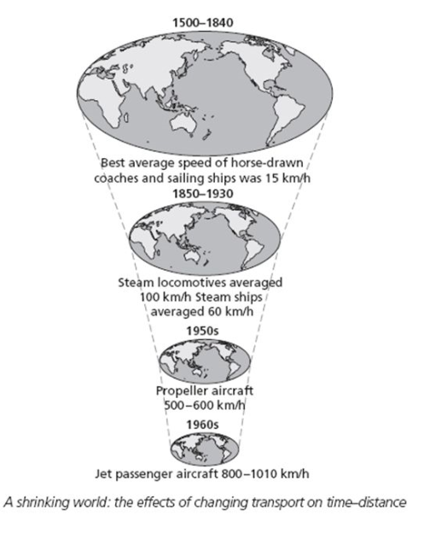**The shrinking world video clip questions:**

1. Up until 500 years ago no one had ___________________ the globe.
2. Why does the world seem like such a smaller place today?
3. How many days does it take humans to go to the moon?
4. Who was the first person to circumnavigate the globe?
5. Between 1857 -1930 the time it took to cross the USA reduced from 3 weeks to _________?
6. In the future where are humans looking to travel?